1 Before powering on the Pi, connect the Sense HAT to the Pi. Start the Pi and once booted, open Python3*.*

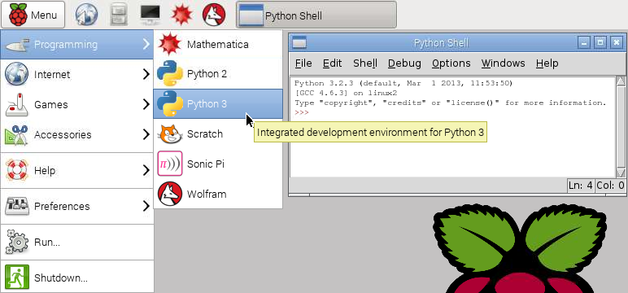

2 From the python shell open a new window (File > New Window). Start by saving this new file to the home directory as rainbow.py. Then start by entering the following lines of code. These import the Sense HAT software and create a sense object. The third line makes sure the display is clear to begin with.

|  |
| --- |
| from sense_hat import SenseHat  sense = SenseHat()  sense.clear() |

2 In smiley.py we previously set the colours of individual pixels using the sense.set_pixel method. This is slow and complex to do for every single pixel. Instead we can define some variables to make a colour palette. In the code below we define variables for the seven colours of the rainbow. The colours are set using RGB (Red Green Blue) values.

|  |
| --- |
| r = [255, 0, 0]  o = [255, 127, 0]  y = [255, 255, 0]  g = [0, 255, 0]  b = [0, 0, 255]  i = [75, 0, 130]  v = [159, 0, 255]  e = [0, 0, 0] # e stands for empty/black |

4 You can then describe a matrix by creating 2D list of colour names

|  |
| --- |
| image = [  e, e, e, e, e, e, e, e,  r, r, r, r, r, r, r, r,  o, o, o, o, o, o, o, o,  y, y, y, y, y, y, y, y,  g, g, g, g, g, g, g, g,  b, b, b, b, b, b, b, b,  i, i, i, i, i, i, i, i,  v, v, v, v, v, v, v, v,  ] |

5 You can then give the image list to the sense.set_pixels method and draw the image.

|  |
| --- |
| sense.set_pixels(image) |

6 Run the program and the LED matrix pixels should show beautiful lines in the colours of the rainbow.

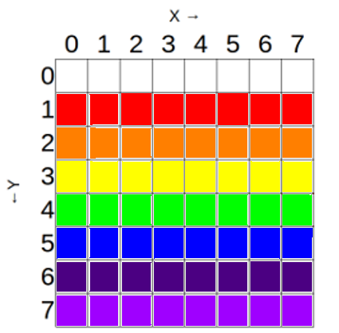

7 Try changing the program so that the coloured lines are curved like a real rainbow. Good luck! *(Hint: try changing the order of the variables in the image list).*